How to install the SCOM Web Console Components GPOs

- Log into your Domain Controller
- Copy over the SCOM2012_Web_Console.zip file and extract to a folder.
- Open up Group Policy Management

- Go to WMI Filters. Right click Import
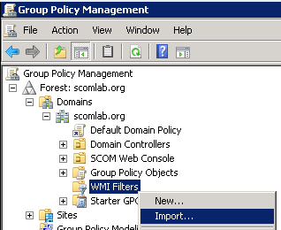

- Import “32-Bit Systems Filter.mof” from extracted zip file folder
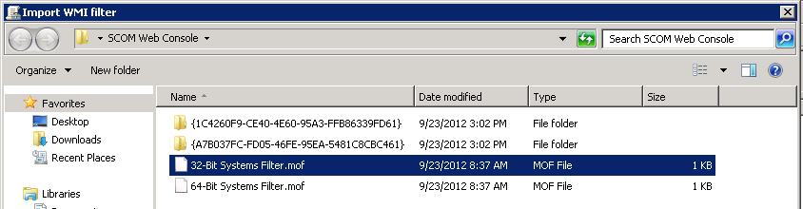

- Click Import
- Import “64-Bit Systems Filter.mof” from extracted zip file folder

- Go to Group Policy Objects. Right click New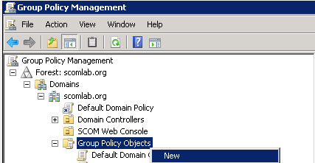

- Call it “SCOM Web Console Components x32”
- Go to Group Policy Objects. Right click New
- Call it “SCOM Web Console Components x64”
You should now have two policies.
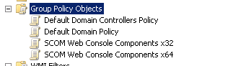
- Right click on SCOM Web Console Components x32 and select Import Setting
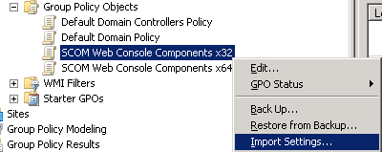

- Select next and then browse to the folder from the extracted zip file

- Select SCOM Web Console Components x32
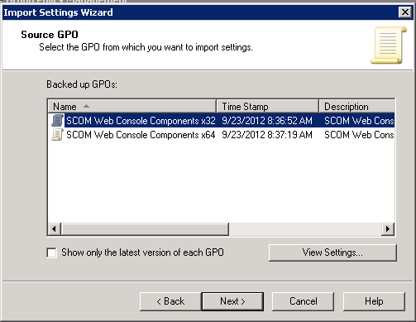

- Select Next, Next, Finish

- Click OK

- Select the GPO you just imported.

- Under WMI Filtering select 32-Bit Systems.
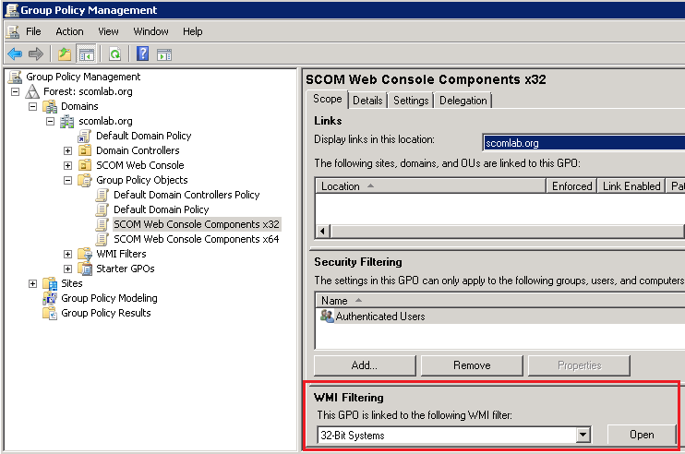

- Click OK

- Repeat steps 13 through 20 for the SCOM Web Console Components x64 GPO but use the SCOM Web Console Components x64 import and Filter.

